The Best Position for Your Child During Mealtime

by [Alisha](https://yourkidstable.com/author/gonzotheweirdo/)

https://yourkidstable.com/best-position-for-your-child-during-mealtime/

\**This post contains affiliate links for your convenience.*

[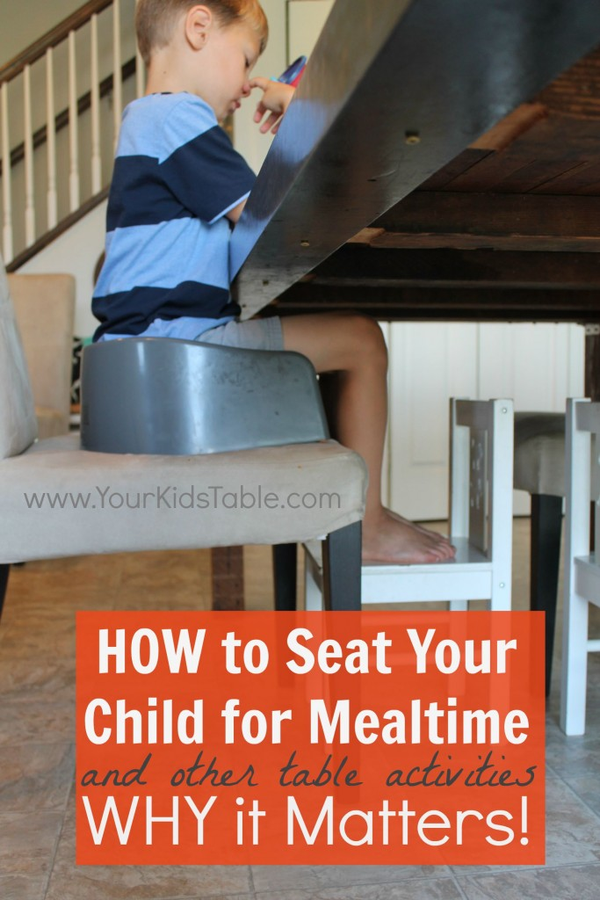](https://yourkidstable.com/wp-content/uploads/2015/08/Proper-Child-Seating-for-Mealtimes.jpg)I am a bit embarrassed that I am now just writing this post after three years of regularly sharing information about kid’s and eating.  How and where your child is sitting to eat can have a HUGE impact on the success of a meal! Surprised? Don’t believe me? I know it sounds like a minor factor to consider when feeding your child (or baby), but if your child isn’t positioned correctly they may have more difficulty swallowing, and thus be more likely to choke.

Additionally, without the proper trunk support, eating may be so taxing that they would rather just skip it, or at least end a meal sooner than they would have. Another wrinkle here is that improper seating often leaves kids very wiggly in their chairs (i.e.: changing positions often, falling off the chair, and leaning on the table or other chairs). These behaviors make it hard for the child to focus on their meal, and are totally distracting for adults.  I often hear parents redirecting their children to “Sit up straight,” or “Don’t lean on the table.” But, if they are sitting in an adult sized chair with nothing under their feet those really aren’t fair requests.

I mentioned this topic briefly in, [Common Mistakes Parents Make](http://yourkidstable.com/2013/05/common-mistakes-parents-make-how-to_20.html), because kids are often very good at manipulating their way into “big boy/girl seats”, and it appears harmless. After all, it does seem a bit easier because you don’t have to strap your child into a booster seat or high chair anymore. Maybe cleaning out the booster is a pain, or getting one is an extra expense? Whatever the reason, I can see how many parents allow their kids to eat on adult chairs. My hope is that I can give you some simple solutions and motivation to make the change so that meal time is easier for your child and less annoying for you. In addition, sitting with support allows for more effective practice of various fine-motor skills (i.e.: cutting, writing, coloring, etc.) and homework.

The Best Position

So here it is, the secret to proper seating: Children should be sitting with their hips, knees, and ankles all bent at 90 degrees. If you can’t think of what that looks like picture each of those joints having an angle like the corner of a perfect square. You may need to get down and look at your child sideways to really determine if you are at 90 degrees. See the pictures below, where I illustrate it in a variety of situations.

[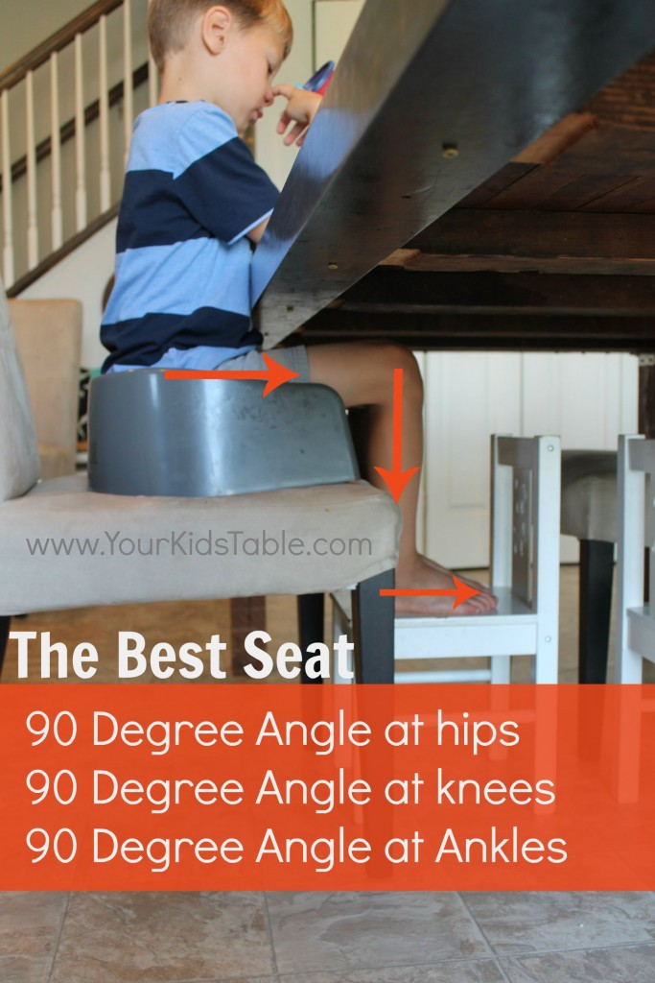](https://yourkidstable.com/wp-content/uploads/2015/08/Best-Seating-Position-for-Kids.jpg)

See how the hips, knees, and ankles are all bent at sharp 90 degree angles.

Child tables are often good solutions for proper positioning, but it is important to still have your kids eating with you at the table. Of course, you can always pull up a chair to their table.

How to Make it Work in Your Home

The easiest, but not necessarily the cheapest, is to invest in an adjustable high-chair that your baby, toddler, and child can use. These chairs allow for lots of different positions to keep your child at 90/90/90.  I have the [Tripp Trapp](http://amzn.to/1WbuPia), (see above pic with baby) and I love it!!! I seriously wish I had got this thing sooner. It’s an investment, but is worth every penny.  I can’t tell you how many of my friends come in and immediately ask me about this chair, or feed their baby or toddler in it AND love how much better they eat.  That’s all because their in the proper position.  There are a few other chairs that are similar to the Tripp Trapp, like [this chair](http://amzn.to/1WbuY5c) and [this one](http://amzn.to/1MX155z). They are all effective because they have adjustable plates that let you move them as your child grows.

**UPDATE:** *My youngest is now two and we are still in love with the Tripp Trapp! Although he doesn’t sit at it anymore, he’s in this* [*strapped booster seat.*](http://amzn.to/2rpFMpF) *My 5 year old, that was super wiggly at meals now sits in it, (it holds up to 300lbs) without all of the seatbelts for babies because those are all remove-able. This thing lasts and has a lot of longevity.*

You may be more interested in booster seats, which are great solutions and are much needed for most kids under 9-10 years old.  There are tons available. For younger kids I use [this one with the strap](http://amzn.to/2rpFMpF) (this is the same one my two year old is using now and my other two also sat in for some time).  I like that this version is easily portable, it folds up nicely. Its come with us plenty of times to parties and dinners.

My oldest, who is now 7, doesn’t need a strap.  He uses [this booster](http://amzn.to/2rYJO5f) and I love it because it is SOOOO easy to clean, at this point in my life that is high on my priority list. Plus, its easy to move and isn’t big and clunky.  Of course, you’re going to want to make sure that their feet are in the proper position.  To do that you will need to experiment with placing phone books, stools, children’s chairs, etc., under their feet, if they aren’t firmly on the ground.

Kids that REALLY Need the Support

I can just about guarantee that if your child has low tone in their trunk than sitting with support is critical to improving their tone, and improving their eating. Otherwise, implementing other strategies to improve eating will likely not be as beneficial. Also, these kids will adopt other strategies that can be harmful while eating to give them the support they need, like “W” sitting.  My oldest has low tone in his trunk and will wrap his legs around the outside of the chair in a “W”, which can lead to hip problems.  Below are some groups of children that commonly display low tone. It is important to note that MANY children (like my Sam) have low tone and no diagnosis.

* Autism
* Down Syndrome
* Cerebral Palsy
* Children born prematurely (in some instances)
* Children that have [chronic constipation](http://yourkidstable.com/2015/02/natural-constipation-relief-for-kids.html) (in some instance)