**Medicaid Provides Essential Care and Services for Individuals with Disabilities**

Medicaid provides health care, long-term services, and community supports to about [332,300](https://www.kff.org/medicaid/state-indicator/distribution-of-medicaid-enrollees-by-enrollment-group/?dataView=0&currentTimeframe=0&sortModel=%7B%22colId%22:%22Location%22,%22sort%22:%22asc%22%7D) Hawaii residents, including [27,200 (or 8%)](https://www.kff.org/medicaid/state-indicator/distribution-of-medicaid-enrollees-by-enrollment-group/?currentTimeframe=0&sortModel=%7B%22colId%22:%22Location%22,%22sort%22:%22asc%22%7D) children and adults living with disabilities. **Easterseals Hawaii specializes in services and supports to help individuals with disabilities or special needs to maintain their health and independence.** Within Medicaid, Easterseals Hawaii partners with the Hawaii Department of Health to provide autism services (Applied Behavior Analysis), case management, community adult day, supported employment, life skills services, nursing services, personal assistance/habilitation, supported employment, and early intervention services, such as occupational, speech, and physical therapies. Easterseals Hawaii annually serves approximately 2,000 individuals and their families each year through Medicaid. **Nalu, a young man from Hawaii who overcame cancer, benefited from Medicaid-funded adult day health and personal assistance and habilitation services provided by Easterseals Hawaii.** Today, Nalu is healthy and working in the community, thanks to the availability of Medicaid services.



*Nalu*

**Medicaid Investments Boost Hawaii Communities and Employers**

Medicaid is also an economic driver for the state of Hawaii. The state receives [$1.21 for every $1](https://www.kff.org/medicaid/state-indicator/federal-matching-rate-and-multiplier/?currentTimeframe=0&sortModel=%7B%22colId%22:%22Location%22,%22sort%22:%22asc%22%7D) it matches through Hawaii’s [54.78 percent federal Medicaid match](https://www.kff.org/medicaid/state-indicator/federal-matching-rate-and-multiplier/?currentTimeframe=0&sortModel=%7B%22colId%22:%22Location%22,%22sort%22:%22asc%22%7D). For fiscal year 2018, Hawaii was scheduled to receive about [$1.38 billion](https://www.cms.gov/About-CMS/Agency-Information/PerformanceBudget/Downloads/FY2018-CJ-Final.pdf) in federal Medicaid funding, which has a profound impact on Hawaii businesses and communities. Easterseals Hawaii is one of the largest providers with [service locations](https://www.eastersealshawaii.org/locations) in Lihue, Waimea and Kapaa on Kauai; Kahului on Maui; Hilo and Kea’au on Hawaii Island; and, in Honolulu, Kapolei, Kailua and Ewa Beach on Oahu. **Annually, Easterseals Hawaii delivers more than $13 million in Medicaid services, which represents more than 80 percent of their total budget. Medicaid directly funds more than 300 Easterseals Hawaii employees, including full-time and part-time case managers, direct care workers, mental health counselors, social workers, and physical, occupational, and speech therapists.** Changes to Medicaid and its funding affect the lives of thousands of families and numerous communities throughout Hawaii.

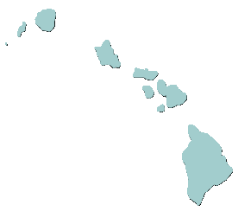

**Funding and Reimbursement Rates to Deliver Medicaid Services is on the Decline**

Easterseals is a national network of community-based and statewide nonprofit organizations that provide Medicaid services and other local supports to individuals with disabilities and others. In a 2018 survey, about 69 percent of Easterseals affiliates reported that their Medicaid funding or reimbursement rates were cut or, at best, stayed the same during the previous year. Of those affiliates who reported Medicaid funding increases, less than 5 percent experienced higher reimbursement rates. The increases were primarily due to serving additional people through Medicaid under existing reimbursement rates.

*2018 Easterseals National Survey*

**Costs to Deliver Medicaid Services on the Rise Despite Flat or Reduced Medicaid Rates**

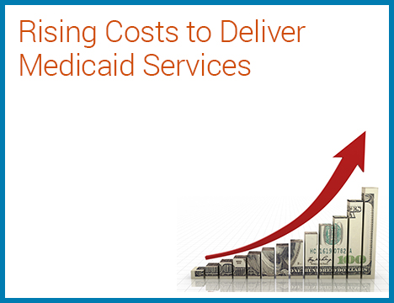

* ***Equipment & Technology***
* ***Health care premiums***
* ***Regulatory & compliance***
* ***Office space rents***
* ***Staff salaries***

Current Medicaid reimbursement rates often fail to meet the true costs to provide high-quality Medicaid home and community-based services. Nationwide, 97 percent of Easterseals affiliates reported their costs to deliver Medicaid services have increased over the past five years—despite cuts to or static reimbursement rates. **Easterseals Hawaii saw their health care premiums, equipment and technology costs, office space rents, staff salaries, and regulatory and compliance costs increase.**

**Programs Closed, Services Reduced and Staff Cut Due to Past Medicaid Cuts**

Flat funding and reimbursement cuts are negatively impacting services and programs for children and adults with disabilities. Service providers, like Easterseals, struggle to operate programs and maintain services under the current fiscal environment. **Past Medicaid cuts have forced Easterseals affiliates to make some difficult decisions, including ending a Medicaid service or closing a service location (68%), laying off staff or terminating unfilled positions (70%), freezing staff pay and benefits (57%), cutting staff pay, benefits, or hours (40%), and reducing service hours (36%).** About 45 percent of Easterseals affiliates recently reported tapping into their limited reserves or endowments to cover program deficits. However, every Easterseals affiliate predicted charitable giving will not make up the loss of future Medicaid funding cuts. In fact, about 62 percent of Easterseals affiliates expect their charitable donations to decrease or remain flat in the future. Also, foundations and other major funders typically do not fund ongoing services and long-term supports, preferring instead to invest in new programs or service models.

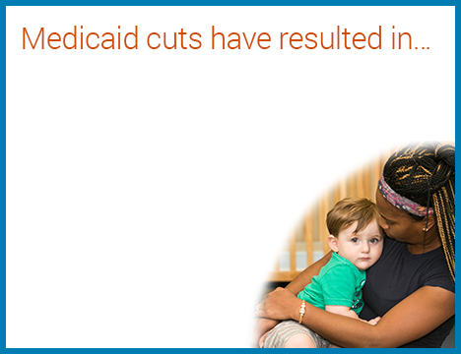

* ***Redirected charitable donations***
* ***Difficulty recruiting staff***
* ***Low staff morale***
* ***Staff departures***

…in Hawaii

* ***Closed or reduced programs & services***
* ***Difficulty recruiting staff***
* ***Low staff morale***
* ***Redirected charitable donations***
* ***Staff departures***
* ***Scaled back services***
* ***Restricted growth of services***

**Medicaid Cuts Will Further Jeopardize Access to Essential Services and Supports**

Future Medicaid funding or reimbursement rate cuts will make it even more difficult for children and adults with disabilities to access the services and supports they need to be successful. **The majority of Easterseals affiliates would likely close programs (57%), lay off staff (51%), or reduce service hours of operation (65.7%) if Medicaid funding or rates are cut further.** The effect would be devastating for individuals and families who are having a harder time receiving services due to limited community provider options (60%), reduced service hours or locations (45%), and eligibility restrictions (45%). **More than 88 percent of Easterseals affiliates reported that their clients would either struggle or be unable to find other service providers in their community that provided the services they needed.**

**Easterseals Opposes Proposals to Cut and Cap Medicaid Funding to the States**

Congressional proposals to convert Medicaid financing from an entitlement program into a state block grant or per capita allotment program would dramatically alter the program and negatively impact individuals with disabilities who meet the program’s eligibility. The current Medicaid structure entitles eligible individuals to core services and, in turn, guarantees states to federal matching payments with no cap to meet program needs of eligible residents.

* The **block grant proposal** would shift Medicaid program costs to states and put Medicaid beneficiaries, including individuals with disabilities, at risk of losing services. Under a block grant, federal Medicaid funding to states would be capped, eliminating the current entitlement structure that allows federal funding to respond to changing program needs, such as recessions, epidemics or disasters. This lack of federal funding flexibility would be passed on to states, who—based on their own financial restrictions—may be forced to limit or end current services to reduce costs. A block grant would also likely end the federal core service components that are required in turn for the federal match.
* The **per capita proposal** would limit the federal government’s reimbursement to states based on a per-enrollee amount. If state Medicaid costs per enrollee increase, due to health care inflation, epidemic or other health circumstance, these costs would shift solely to states given the federal reimbursement is capped. Reductions in critical services to individuals with disabilities and other Medicaid beneficiaries or higher program premiums would be likely cost-reduction strategies, especially for states that have limited revenue flexibility.

**Easterseals Position on Medicaid Reform**

Easterseals respectfully asks Congress to protect Medicaid funding, not only for individuals with disabilities, but also for those who provide these critical services by:

* ***Opposing proposals that remove Medicaid’s guarantee of services to eligible populations;***
* ***Opposing proposals that convert Medicaid to block grant or per capita financing;***
* ***Maintaining Medicaid’s current structure that guarantees states a federal funding formula match, based on eligibility costs, without a federal cap;***
* ***Ensuring Medicaid reform doesn’t shift costs to individuals or reduce services; and***
* ***Advancing policies that allow more Medicaid services to be delivered in home and community-based settings.***